**FLEX BOX IN CSS**

The Flexible Box Layout Module, makes it easier to design f**lexible responsive layout structure without using float or positioning.**

**FLEX CONTAINER:**

An area of a document laid out using flexbox is called a **flex container**. To create a flex container, we set the value of the area's container's [display](https://developer.mozilla.org/en-US/docs/Web/CSS/display) property to flex or inline-flex. As soon as we do this the direct children of that container become **flex items**.

**d-flex in bootstrap:**

The d-flex class is used to create a full-screen width flexbox container and convert the items into it. On the other hand, d-flex-inline class also creates a flexbox container, but its width is customized.

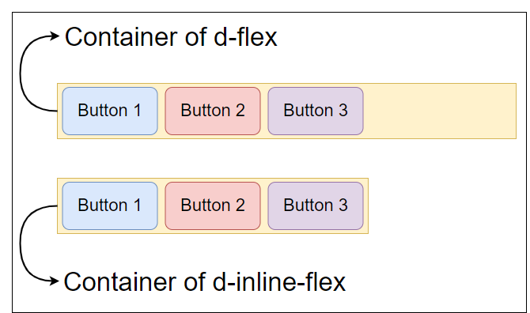

**Media Queries:**

Media queries allow you to apply CSS styles depending on a device's general types or other characteristics such as screen resolution or browser viewport width. Media queries are used for the following: To conditionally apply styles with the CSS

**@media screen and @import at-rules (max-width/min-width:px)**

**Key Frames:**

In CSS, keyframes are used for animations. It gives you more control over the animation you want to perform. The animation is created by gradually changing from one style to another.